The Schema Relation with Tools
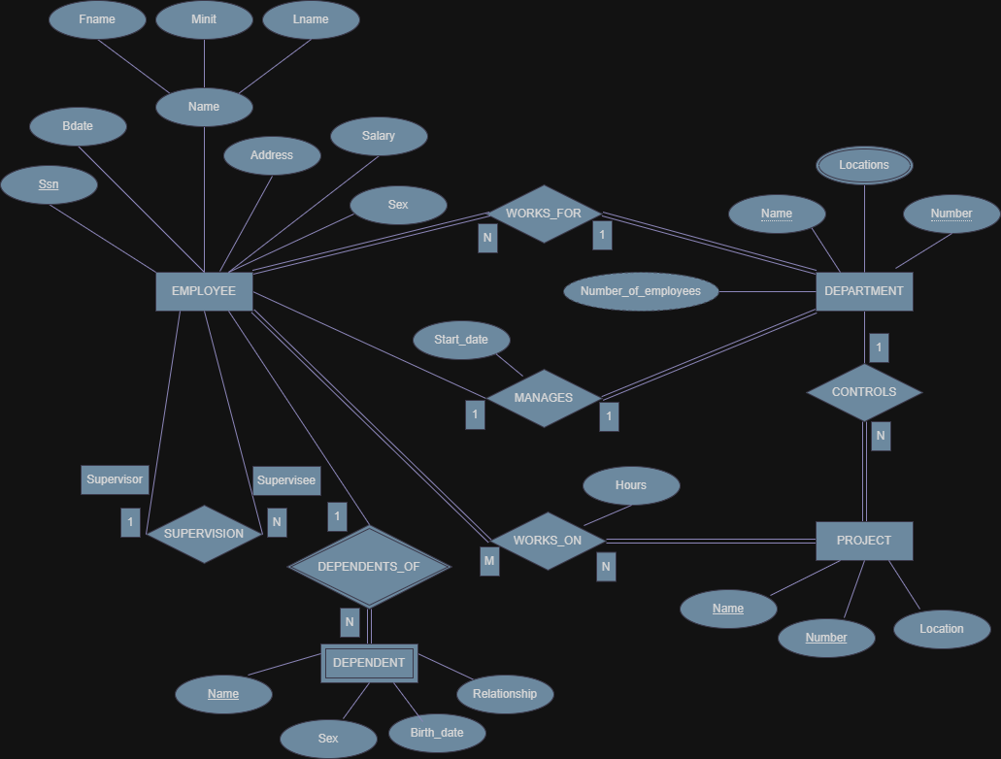
- Primary key
A primary key is an attribute used to uniquely identify each record in an entity so that no two records have the same value. In the ER diagram, each entity has an attribute that functions as a primary key. For example, in the EMPLOYEE entity, the attribute Ssn is the primary key because each employee has a unique identification number. In the DEPARTMENT entity, the attribute Number serves as the primary key that distinguishes each department. In the PROJECT entity, the attribute Number is also used as the primary key to differentiate each project. Meanwhile, in the DEPENDENT entity, the attribute Name is usually considered a partial key because its identification depends on the EMPLOYEE entity.

- Foreign key
A foreign key is an attribute in one table that is used to connect that table with another table through the primary key of the other table. In this ER diagram, foreign keys appear after the ERD is transformed into relational tables. For example, in the WORKS_FOR relationship, the EMPLOYEE entity is related to the DEPARTMENT entity, so the Number attribute from DEPARTMENT will become a foreign key in the EMPLOYEE table. In the WORKS_ON relationship, the relationship table will store Ssn from EMPLOYEE and Number from PROJECT as foreign keys. Additionally, in the SUPERVISION relationship, the Ssn attribute from EMPLOYEE can also become a foreign key to represent the relationship between a supervisor and a supervisee.

- Relationship and its degree
A relationship is a connection that occurs between two or more entities in a database system. The degree of a relationship indicates the number of entities involved in that relationship. In the ER diagram, most relationships have a binary degree (two entities), such as the WORKS_FOR relationship between EMPLOYEE and DEPARTMENT with N:1 cardinality, which means many employees can work for one department. The MANAGES relationship is also between EMPLOYEE and DEPARTMENT with a 1:1 cardinality. The WORKS_ON relationship between EMPLOYEE and PROJECT has an M:N cardinality because one employee can work on multiple projects and one project can involve multiple employees. There is also a SUPERVISION relationship that shows a 1:N relationship where one employee acts as a supervisor for multiple employees. Therefore, most relationships in the diagram are binary relationships with variations of cardinality such as 1:1, 1:N, and M:N.

